The age of peace and legend is gone… now dawns the Age of War!

Stormfall: Age of War
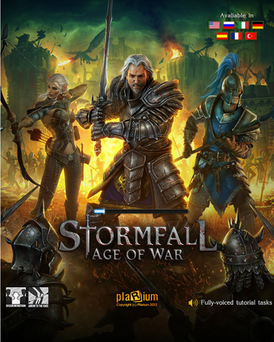
Step into a dark world of fantasy and myth, of ancient magic, dragons, destiny, and heroes. The empire of Stormfall has descended into chaos, and the days grow darker as rival warlords battle for power and ancient evils rise once again. The empire is in dire need of a great warrior who can claim the throne and restore Stormfall to its former glory. You have been chosen by the gods to be a champion in these dark times – a lord with enough strength to reunite the seven kingdoms of the empire.

To claim your right, you must raise a mighty castle, master the art of trade, and arm yourself with sorcery and valuable resources. You must raise a strong army and strategically align with other lords in a world where treachery may be the key to survival. Find the cunning to survive and the will to conquer as you fight to defend the throne of Stormfall. The age of peace and legend is gone… now dawns the Age of War!

Key Features

- Build Your Castle
- Construct an empire from the ground up with mines, farms, guilds, and markets.
- Acquire three main resources – food, gold, and iron – to construct buildings, discover Lost Arts, and sustain strong military forces.
- Visit competing castles and compare rankings with global players and friends.

- Immerse Yourself in the Plotline
- This real-time interface is intuitive for both seasoned genre fans and casual social gamers to join the story.
- Fully voiced narratives will guide players through massive in-game storyline developments and interactions with non-player opponents.

- Defend Your Empire
- There isn’t a wrong way to win – players can defend their castle alone, or form alliances with fellow lords.
- Gather armies to defend the throne. Recruit barbarians, paladins, knights, shades, and dragons to march under your banner.
- Acquire resources through raids and trades.

- Experience a Medieval Fantasy
- Detailed artwork and graphics will appeal to fans of medieval plotlines and folklore.
- Updates are regularly made available to assist players in efficiently building castles, laying sieges, and earning key resources.
- Fully translated and voiced in English, French, Spanish, Italian, German, Russian, and Turkish.

Product Specifications

Publisher: Plarium
Developer: Plarium
Category: MMRTS (Massively Multi-Player Real-Time Strategy)
Platform: Facebook
MSRP: FREE
Release: November 1, 2012

© 2012 Plarium. All Rights Reserved. Plarium, Stormfall, Stormfall Age of War, and their respective logos are trademarks or registered trademarks of Plarium.

