Soldiers Inc.
In this future, war is a business...and business is good.

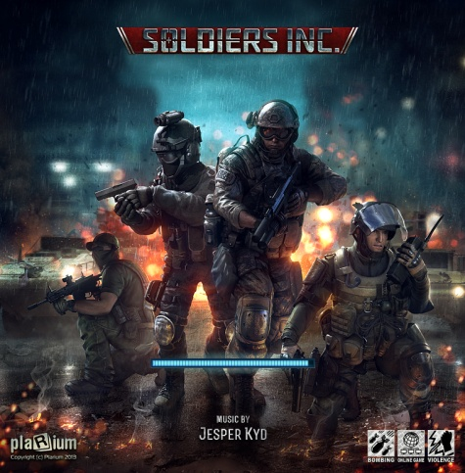
The year is 2019. International corporate powers struggle over dwindling resources and the discovery of the largest deposit of minerals in the known world has turned the Former Republic of Zandia into a corporate war zone - a black ops free-for-all waged by a new breed of legal mercenaries.

Take control of the world’s most elite private military contractors under the guidance of your shadowy mentor. This conflict will be fought by the best and won by the most ruthless – so grab your kit, bring your friends, pack plenty of ammo, and trust no one. In Zandia, war is big business… and business is good.

Key Features

Core Quality  - Top-quality artwork and modeling with the level of detail demanded by serious players  - Classic real-time interface makes joining the fight intuitive for all levels of RTS gamer.  - Regular updates, new content, missions, and characters fuel an ever expanding plotline.  AAA Caliber Voiceovers and Original Music  - Learn the basics of command from your Syndicate handler, Mr. Black. His fully-voiced tutorial will walk you through gameplay essentials like contracting, combat, and joint operations.  - Fully-scored soundtrack and sound composed and produced by BAFTA award-winning composer Jesper Kyd.  - Fully translated and voiced in English, French, Spanish, Italian and German. | Hardcore MMORTS Gameplay  - Play with millions of hardcore players with a passion for deep strategy. Victory goes to those who choose their friends wisely, but aren’t afraid to get their hands dirty solo. Allies and enemies can change at the drop of a bullet casing.  - Join Partnerships, form Tactical Combines, use live chat, and participate in Joint Operations to maximize your impact on the battlefield.  Build Your Base of Operations  - Exploit, steal, trade, or borrow the war materiel you need to turn your outpost into a fortress.  - Defend yourself with the latest in automated gun turrets, artillery, tank traps, and more.  Command the Most Lethal Forces on the Market  - Hire and deploy over 30 realistic units, mercenaries, and battlefield systems from the world’s most modern arsenals.

Product Specifications

Publisher: Plarium
Developer: Plarium
Category: MMO RTS (Massively Multi-Player Online Real-Time Strategy)
Platform: Facebook
MSRP: FREE
Release: August 1, 2013

© 2013 Plarium. All Rights Reserved. Plarium, Soldiers Inc. and their respective logos are trademarks or registered trademarks of Plarium.

