ALIEN VS. PREDATOR EVENT FOR FACEBOOK
As featured in Soldiers, Inc.

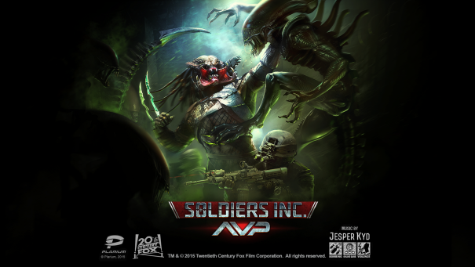
Plarium teamed up with Twentieth Century Fox Consumer Products to create a 90-day “Alien vs. Predator” (AVP) event within Soldiers Inc., its popular Facebook game.

The AVP campaigns will be a fully-voiced, entirely separate experience within the original game. Players will meet new characters, join new allies, and fight terrifying new opponents as they race to investigate a temple of unknown origin before a thermonuclear detonation.

- New Characters and Story Campaigns
- Players get the chance to work with the Weyland Corporation’s top Xenobiologist to turn Aliens into devastating living weapons.
- The player’s Syndicate handler, Mr. Black, has returned! Help him acquire unknown Predator weapons technology before the clock runs out!
- Players can follow both the Alien and Predator campaigns separately or in parallel. Each campaign has 12 consecutive fully-voiced missions.
- New Building, Map Locations, and Items
- Construct the Weyland Field Laboratory in your base to build new Alien and Predator Units.
- New items (Artifacts) can be used to create each clone.
- New locations and excavation sites will be uncovered across Zandia. Players will have to capture and hold these sites using their new units to collect Artifacts.
- New Tournaments:
- Introducing special new AVP-themed PvP Tournaments!
- Players can engage each other in battle at their bases or other sites and compete to collect the most Skull trophies.
- New AVP prize packs will be offered for top performers in these events!
- 13 Limited-Edition Units
- The event introduces 5 all-new Alien units and 5 all-new Predator units. Players will be able to train powerful Alien and Predator clones to fight alongside their regular forces!
- Three special new Strategic Units:
  - Predator Ancient - boosts the offensive and defensive capabilities of any Predators it accompanies into battle.
  - Alien Queen – boosts offensive and defensive capabilities of any Aliens.
  - Predalien - the strongest unit to appear in Soldiers Inc. to date - affects both new types of Units!

Product Specifications

Publisher: Plarium
Developer: Plarium
Category: MMO Strategy (Massively Multiplayer Online Strategy)
Platform: Facebook
MSRP: FREE
Release: November 10, 2015

Alien, Predator, Xenomorph, Predalien, AVP, AVP 2, TM & © 2015 Twentieth Century Fox Film Corporation. All rights reserved. Twentieth Century Fox, Alien, AVP and their associated logos are registered trademarks or trademarks of Twentieth Century Fox Film Corporation. Soldiers Inc. game platform, excluding Twentieth Century Fox elements © Plarium Global LTD. Plarium, Soldiers Inc., and their respective logos are trademarks or registered trademarks of Plarium Global LTD. All rights reserved.

