RIO: MATCH 3 PARTY FOR IOS AND ANDROID

Rio: Match 3 Party

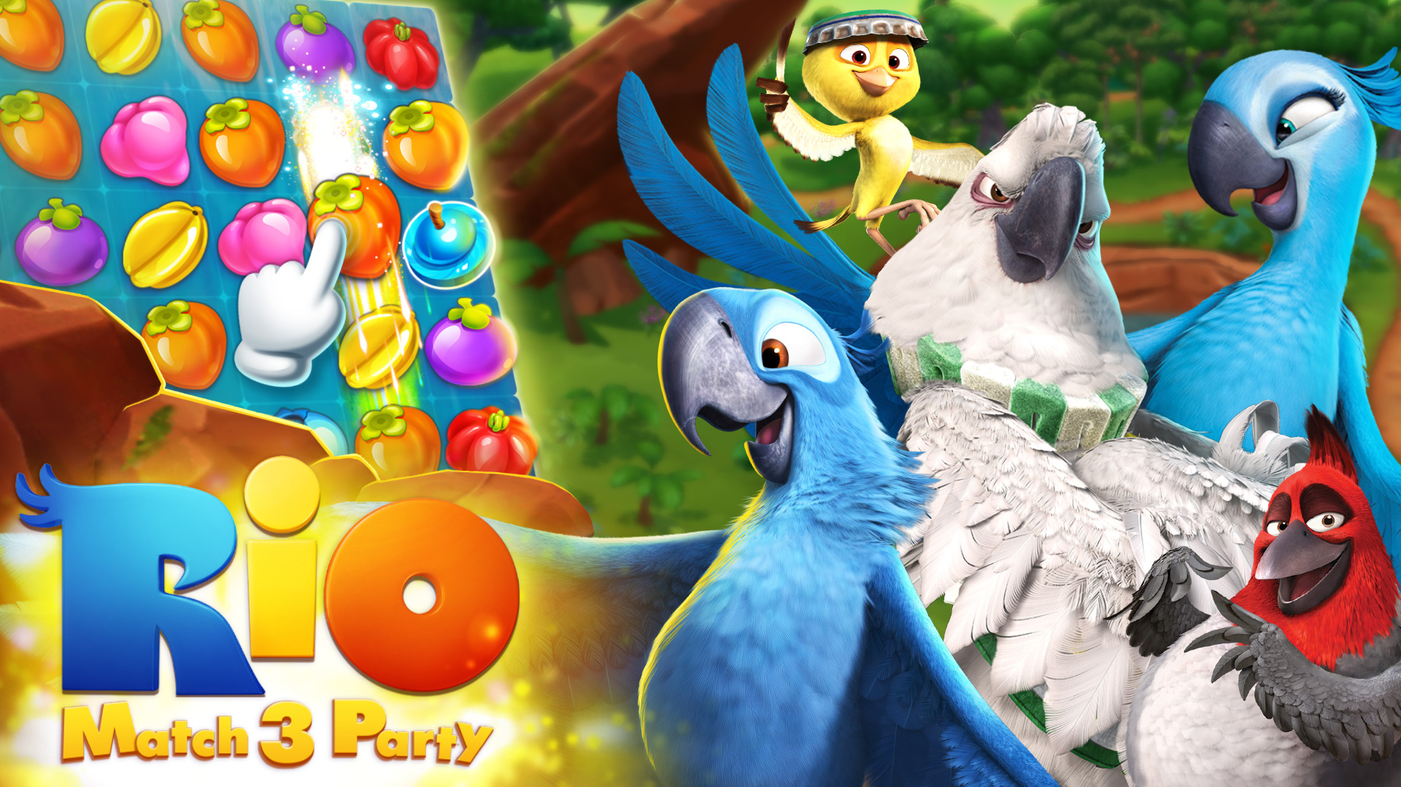
Rio: Match 3 Party is a family-friendly Match 3 adventure combining fun, fast-paced puzzle mechanics with the vibrant star-studded world of the Rio franchise.

Players will explore the jungles of the Amazon and the streets of Rio de Janeiro as they help Blu, Jewel, Nico, Pedro and the rest of the Rio gang throw the best parties Brazil has ever seen! From stunning locations and colorful stories, to 15+ hours of fully-voiced interactive character dialogue including Jesse Eisenberg returning as Blu, Rio comes to the mobile screen like never before!

Players will work their way through hundreds of Match 3 levels as they master special challenges, meet new characters, unlock special abilities, and collect everything they need to throw parties across the exciting destinations from the films. With offline and online gameplay modes, players can go it alone or play with their friends for top scores, free gifts, and tournament rankings.

Key Features

Swipe & Match Your Way Through Rio
- Match, swipe, and crush your way through hundreds of levels.
- Go back and master them for a tougher challenge - with bigger rewards.
- Explore the Amazon Jungle, Rio City, and the Vista Chinesa - with more movie locations on the way!
- Complete new levels to watch the map come alive as you add balloons, disco balls, music, and everything you need for the party!
- Watch it all come together as you finish each location with awesome animated bashes!
- Play both online and offline game modes.
Party With All Your Feathered Friends

- Collect all your favorite characters from the Rio universe - including Blu, Nigel, Nico, Jewel, and more - all in full 3D!
- Fully-voiced performances by all of the Rio gang.
- Befriending new characters unlocks new special abilities to mix up your gameplay.
- Send and receive gifts with your Facebook friends.
- See your friends’ top scores on your map, then join them in friendly challenges.
- Compete in tournaments for prizes.

Product Specifications
Publisher: Plarium
Developer: Plarium
Category: Puzzle
Platform: iOS, Android
MSRP: FREE
Release: March 23rd, 2017

Multi-language support: English, Russian, German, French,
Spanish, Italian, Turkish, Portuguese
Korean, Japanese, Simplified and Traditional Chinese
Rio TM & © 2017 Twentieth Century Fox Film Corporation. All Rights Reserved. Rio: Match 3 Party game software, excluding Twentieth Century Fox elements, © 2017 Plarium Global Ltd. All Rights Reserved. Plarium and its respective logos are trademarks or registered trademarks of Plarium Global Ltd.

