MAIN CHARACTERS

ELHAIN
Elhain is a High Elf Attack Champion who specializes in dealing massive Critical Damage and multi-attacks.

Skills-Keen Shot

Attacks 1 enemy. Places an extra hit if this attack is critical.
Keen Shot is a straightforward and effective attack. Make sure Elhain has a high C.Rate and watch her destroy single targets with double-hits.
Lightning Arrow

Attacks 1 enemy, then all enemies. Has an extra 15% chance of inflicting a critical hit. Places a 30% [Increase C.RATE] buff on this Champion for 3 turns if the target is killed. Cooldown: 4 turns (initial - 5 turns)

Lightning Arrow is an AoE attack that deals additional damage to the original target. Due to the buff, it gives Elhain upon killing an enemy, it is usually wise to select a target with the lowest HP in order to make Elhain even more dangerous in the coming turns.
Valley of Death.

Attacks all enemies 2 times.

KAEL
Kael is a Dark Elf Attack Champion who applies numerous Continuous Damage effects to his enemies and gains Turn Meter by defeating them.  Skills-Dark Bolt  Attacks 1 enemy. Has an 80% chance of placing a 2,5% [Poison] debuff for 2 turns.  Kael’s primary attack has a fairly high chance of placing a Continuous Damage effect on the target, adding a fairly nasty [Poison] debuff that can and will accumulate over time into significant damage. | 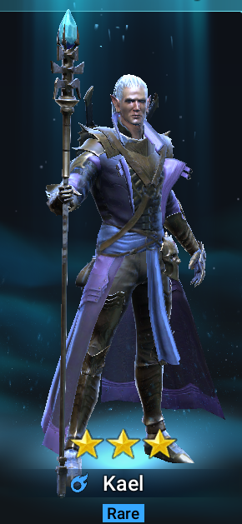

GALEK
Galek is an Orc Attack Champion who increases his Speed and decreases enemy Defense.  Skills-Cross Slash  Attacks 1 enemy 2 times.  Attacks all enemies. Has an extra 15% chance of inflicting a critical hit. Places a 30% [Increase SPD] buff on this Champion for 2 turns. Cooldown: 4 turns (initial - 5 turns). | 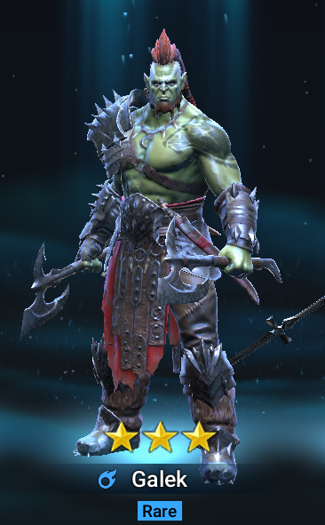

ATHEL
In terms of game mechanics, Athel is a Sacred Order Attack Champion who weakens enemies, buffs herself and inflicts devastating AoE damage.  Skills-Strike Down  Attacks 1 enemy 3 times. Has a 75% chance of placing a 25% [Weaken] debuff for 2 turns on the last hit.  This is a multi-hit Attack that deals significant damage to its target and, most importantly, applies a [Weaken] debuff that will make the enemy suffer 25% more damage from all incoming attacks for 2 turns.  Divine Blades  Attacks all enemies. Has an extra 15% chance of inflicting a Critical Hit. Cooldown: 3 turns.  A fairly simple AoE attack that deals direct damage to all targets and has an increased Critical Crate.  Higher Blessing  Places a 50% [Increase ATK] buff on this Champion for 3 turns. Places a 60% [Increase DEF] buff on this Champion for 3 turns if this Champion’s HP is less than 50%. Gains and Extra Turn. Cooldown: 4 turns (initial - 5 turns). | 